Mexican Spanish CDI III

Norming Figures and Tables

June 2, 2023

Figure 1. Percentiles for vocabulary production as a function of age – both sexes combined

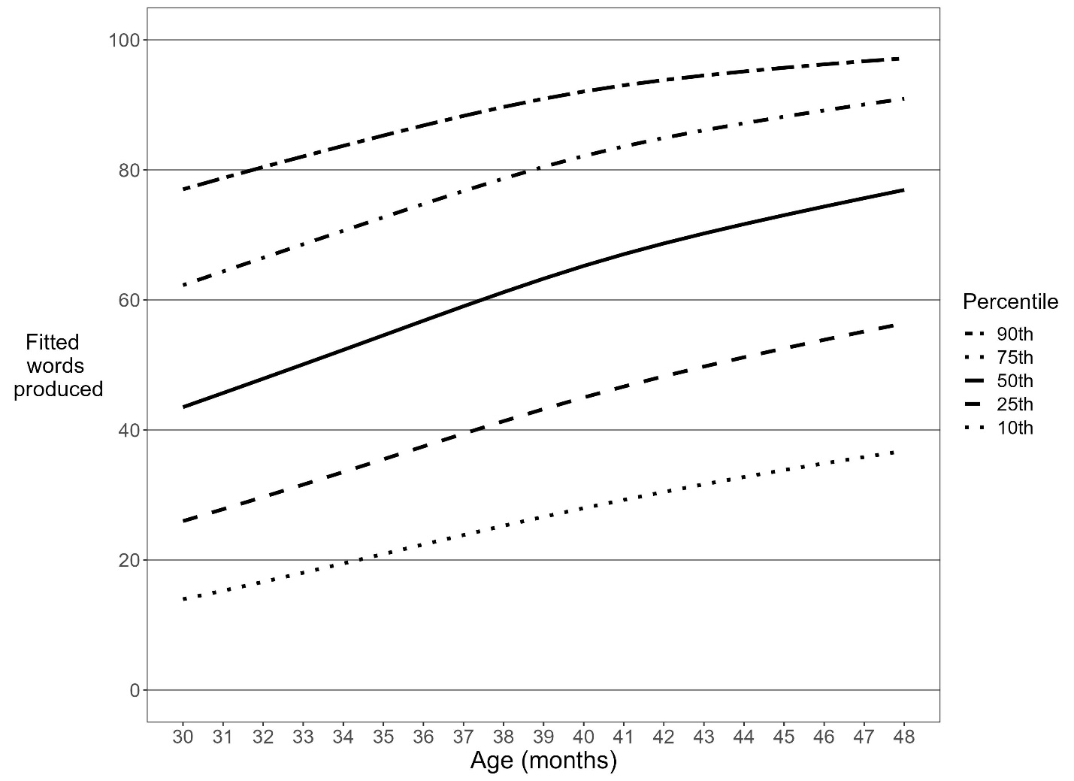

Figure 2. Percentiles for vocabulary production as a function of age – girls

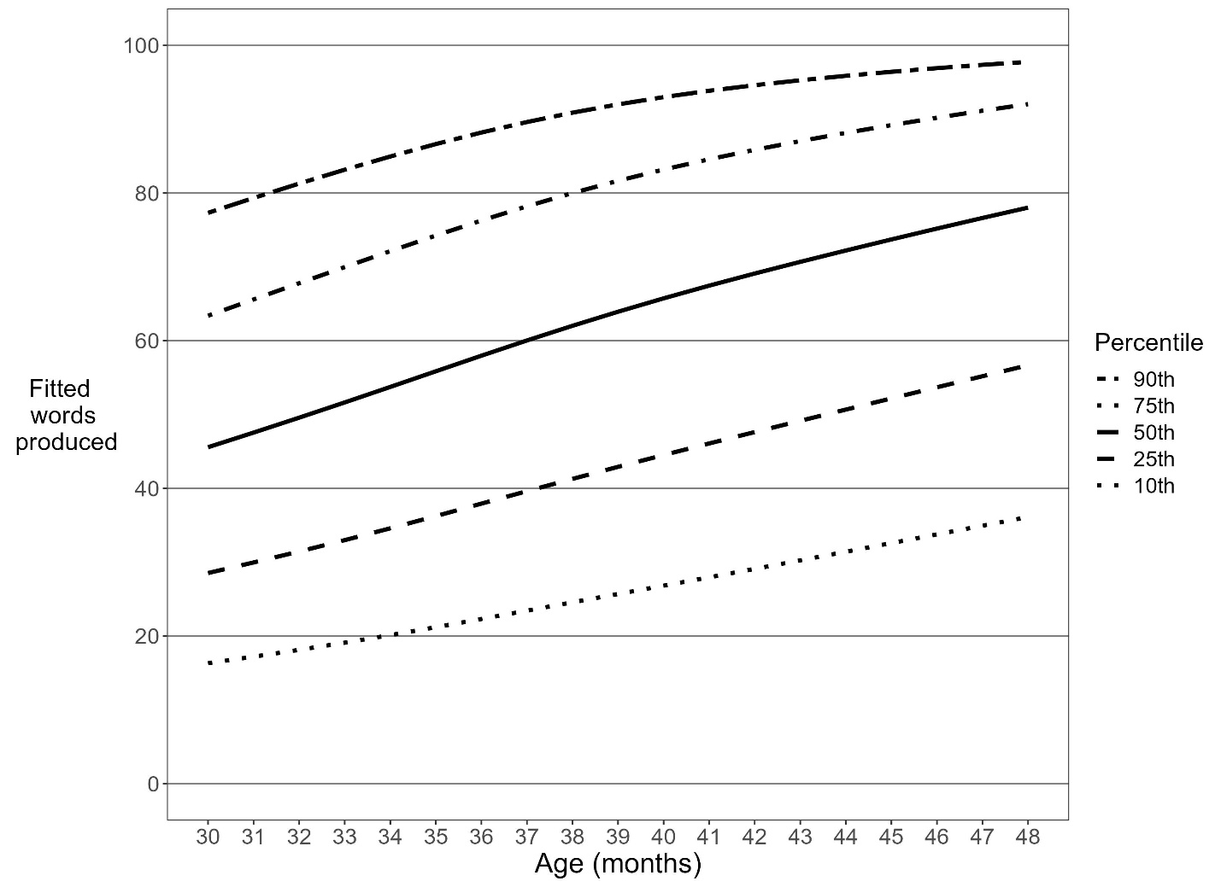

Figure 3. Percentiles for vocabulary production as a function of age – boys

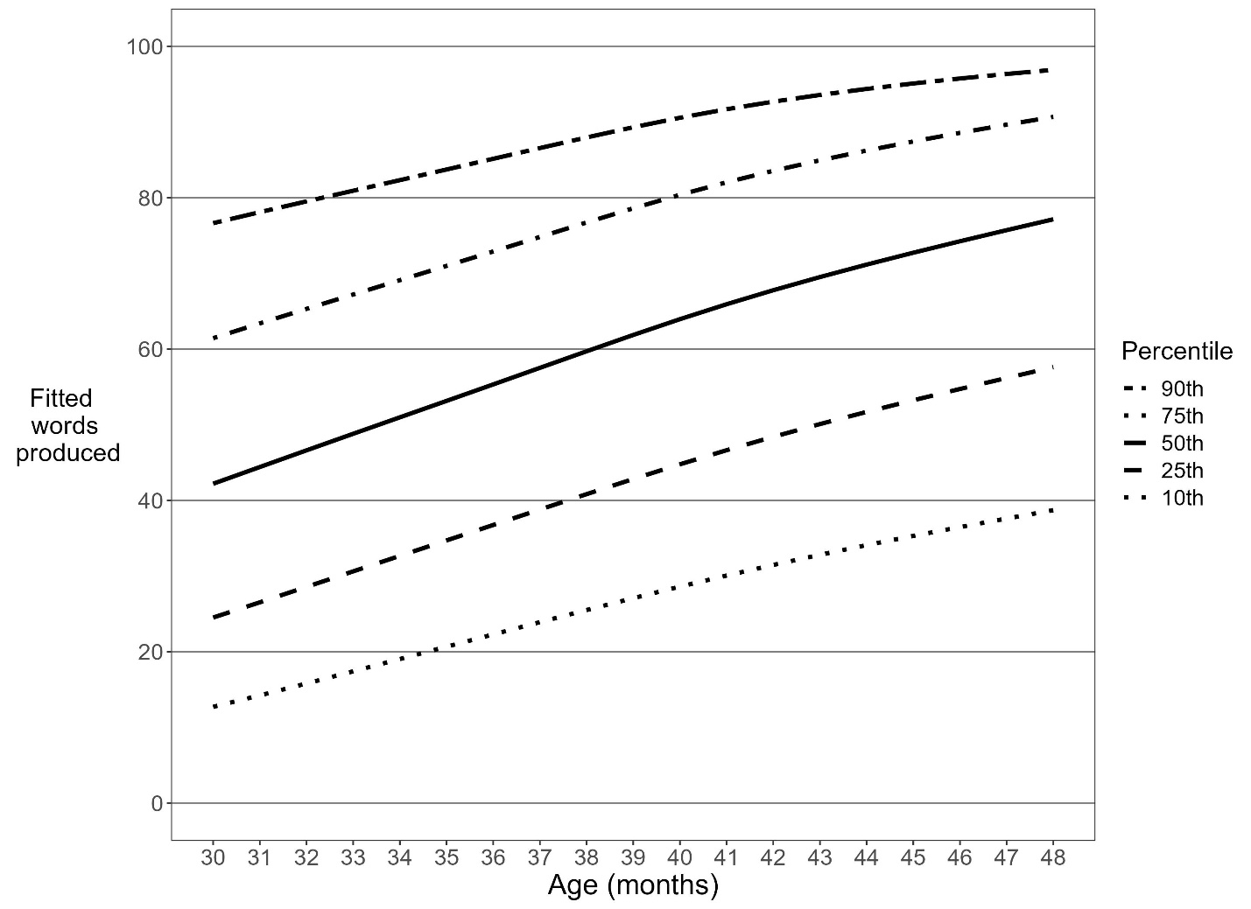

Figure 4. Percentiles for complexity score as a function of age – both sexes combined

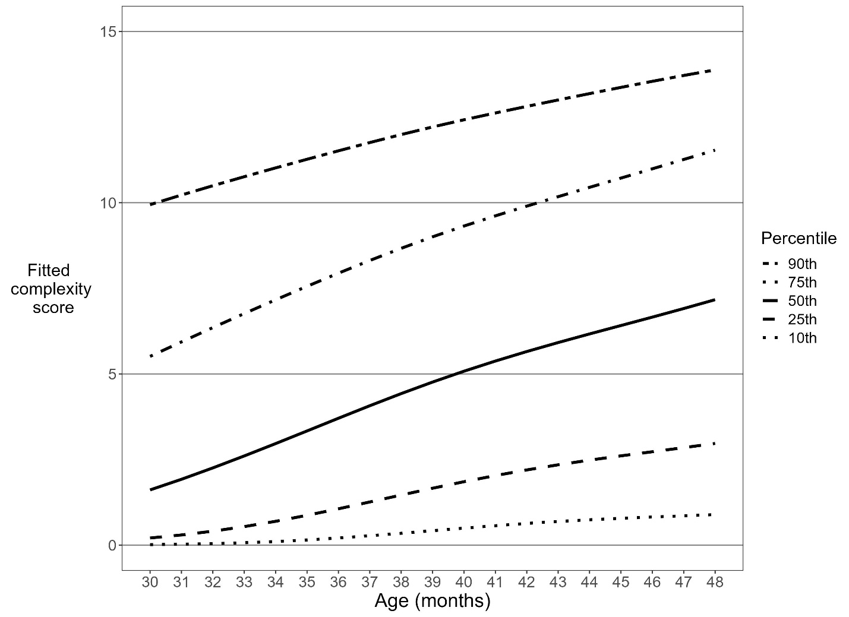

Figure 5. Percentiles for complexity score as a function of age – girls

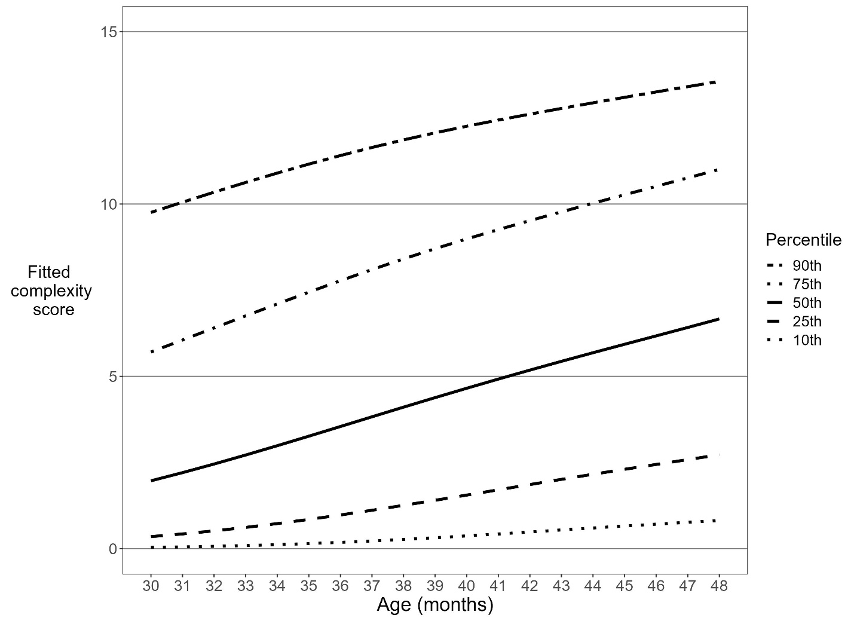

Figure 6. Percentiles for complexity score as a function of age – boys

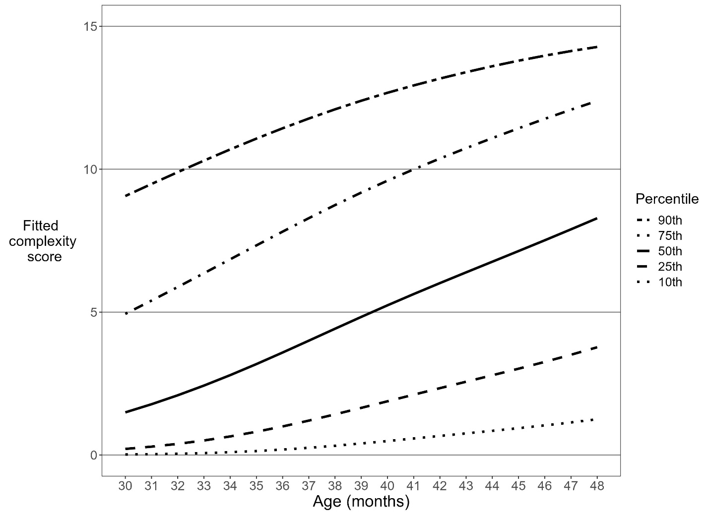

Table 1. Full percentiles for vocabulary production as a function of age – both sexes combined

|  |  |  |  |  |  |  |  |  |  |  |  |  |  |  |  |  |  |  |  |
| --- | --- | --- | --- | --- | --- | --- | --- | --- | --- | --- | --- | --- | --- | --- | --- | --- | --- | --- | --- |
|  | 30 | 31 | 32 | 33 | 34 | 35 | 36 | 37 | 38 | 39 | 40 | 41 | 42 | 43 | 44 | 45 | 46 | 47 | 48 |
| 99 | 93 | 94 | 95 | 95 | 96 | 97 | 97 | 98 | 98 | 99 | 99 | 99 | 99 | 99 | 100 | 100 | 100 | 100 | 100 |
| 95 | 84 | 85 | 87 | 88 | 89 | 91 | 92 | 93 | 94 | 95 | 96 | 96 | 97 | 97 | 98 | 98 | 98 | 99 | 99 |
| 90 | 77 | 79 | 80 | 82 | 84 | 85 | 87 | 88 | 90 | 91 | 92 | 93 | 94 | 95 | 95 | 96 | 96 | 97 | 97 |
| 85 | 71 | 73 | 75 | 77 | 79 | 81 | 83 | 84 | 86 | 87 | 89 | 90 | 91 | 92 | 93 | 93 | 94 | 95 | 95 |
| 80 | 67 | 69 | 71 | 73 | 75 | 77 | 79 | 80 | 82 | 84 | 85 | 87 | 88 | 89 | 90 | 91 | 92 | 92 | 93 |
| 75 | 62 | 64 | 66 | 69 | 71 | 73 | 75 | 77 | 79 | 80 | 82 | 84 | 85 | 86 | 87 | 88 | 89 | 90 | 91 |
| 70 | 58 | 60 | 63 | 65 | 67 | 69 | 71 | 73 | 75 | 77 | 79 | 80 | 82 | 83 | 84 | 85 | 87 | 88 | 89 |
| 65 | 54 | 57 | 59 | 61 | 63 | 65 | 68 | 70 | 72 | 74 | 76 | 77 | 79 | 80 | 81 | 83 | 84 | 85 | 86 |
| 60 | 51 | 53 | 55 | 57 | 59 | 62 | 64 | 66 | 68 | 70 | 72 | 74 | 76 | 77 | 78 | 80 | 81 | 82 | 83 |
| 55 | 47 | 49 | 51 | 54 | 56 | 58 | 60 | 63 | 65 | 67 | 69 | 71 | 72 | 74 | 75 | 76 | 78 | 79 | 80 |
| 50 | 44 | 46 | 48 | 50 | 52 | 55 | 57 | 59 | 61 | 63 | 65 | 67 | 69 | 70 | 72 | 73 | 74 | 76 | 77 |
| 45 | 40 | 42 | 44 | 47 | 49 | 51 | 53 | 55 | 58 | 60 | 62 | 63 | 65 | 67 | 68 | 69 | 71 | 72 | 73 |
| 40 | 37 | 39 | 41 | 43 | 45 | 47 | 49 | 52 | 54 | 56 | 58 | 60 | 61 | 63 | 64 | 66 | 67 | 68 | 70 |
| 35 | 33 | 35 | 37 | 39 | 41 | 43 | 46 | 48 | 50 | 52 | 54 | 56 | 57 | 59 | 60 | 62 | 63 | 64 | 66 |
| 30 | 30 | 32 | 33 | 35 | 38 | 40 | 42 | 44 | 46 | 48 | 50 | 51 | 53 | 54 | 56 | 57 | 59 | 60 | 61 |
| 25 | 26 | 28 | 30 | 32 | 34 | 35 | 37 | 39 | 41 | 43 | 45 | 47 | 48 | 50 | 51 | 53 | 54 | 55 | 56 |
| 20 | 22 | 24 | 26 | 27 | 29 | 31 | 33 | 35 | 37 | 38 | 40 | 42 | 43 | 45 | 46 | 47 | 48 | 50 | 51 |
| 15 | 18 | 20 | 21 | 23 | 25 | 26 | 28 | 30 | 31 | 33 | 34 | 36 | 37 | 39 | 40 | 41 | 42 | 43 | 45 |
| 10 | 14 | 15 | 17 | 18 | 19 | 21 | 22 | 24 | 25 | 27 | 28 | 29 | 30 | 32 | 33 | 34 | 35 | 36 | 37 |
| 5 | 9 | 10 | 11 | 12 | 13 | 14 | 15 | 16 | 18 | 19 | 20 | 21 | 22 | 22 | 23 | 24 | 25 | 26 | 26 |

Table 2. Full percentiles for vocabulary production as a function of age – girls

|  |  |  |  |  |  |  |  |  |  |  |  |  |  |  |  |  |  |  |  |
| --- | --- | --- | --- | --- | --- | --- | --- | --- | --- | --- | --- | --- | --- | --- | --- | --- | --- | --- | --- |
|  | 30 | 31 | 32 | 33 | 34 | 35 | 36 | 37 | 38 | 39 | 40 | 41 | 42 | 43 | 44 | 45 | 46 | 47 | 48 |
| 99 | 93 | 94 | 95 | 96 | 97 | 97 | 98 | 98 | 99 | 99 | 99 | 99 | 99 | 100 | 100 | 100 | 100 | 100 | 100 |
| 95 | 84 | 86 | 87 | 89 | 90 | 92 | 93 | 94 | 95 | 96 | 96 | 97 | 97 | 98 | 98 | 98 | 99 | 99 | 99 |
| 90 | 77 | 79 | 81 | 83 | 85 | 87 | 88 | 90 | 91 | 92 | 93 | 94 | 95 | 95 | 96 | 96 | 97 | 97 | 98 |
| 85 | 72 | 74 | 76 | 78 | 80 | 82 | 84 | 86 | 87 | 89 | 90 | 91 | 92 | 93 | 93 | 94 | 95 | 96 | 96 |
| 80 | 68 | 70 | 72 | 74 | 76 | 78 | 80 | 82 | 84 | 85 | 86 | 88 | 89 | 90 | 91 | 92 | 93 | 93 | 94 |
| 75 | 63 | 66 | 68 | 70 | 72 | 74 | 76 | 78 | 80 | 82 | 83 | 85 | 86 | 87 | 88 | 89 | 90 | 91 | 92 |
| 70 | 60 | 62 | 64 | 66 | 68 | 70 | 73 | 75 | 76 | 78 | 80 | 81 | 83 | 84 | 85 | 86 | 88 | 89 | 90 |
| 65 | 56 | 58 | 60 | 62 | 65 | 67 | 69 | 71 | 73 | 75 | 76 | 78 | 80 | 81 | 82 | 84 | 85 | 86 | 87 |
| 60 | 52 | 54 | 57 | 59 | 61 | 63 | 65 | 67 | 69 | 71 | 73 | 75 | 76 | 78 | 79 | 80 | 82 | 83 | 84 |
| 55 | 49 | 51 | 53 | 55 | 57 | 60 | 62 | 64 | 66 | 68 | 69 | 71 | 73 | 74 | 76 | 77 | 79 | 80 | 81 |
| 50 | 46 | 48 | 50 | 52 | 54 | 56 | 58 | 60 | 62 | 64 | 66 | 67 | 69 | 71 | 72 | 74 | 75 | 77 | 78 |
| 45 | 42 | 44 | 46 | 48 | 50 | 52 | 54 | 56 | 58 | 60 | 62 | 64 | 65 | 67 | 68 | 70 | 72 | 73 | 74 |
| 40 | 39 | 41 | 43 | 44 | 46 | 48 | 50 | 52 | 54 | 56 | 58 | 60 | 61 | 63 | 65 | 66 | 68 | 69 | 71 |
| 35 | 36 | 37 | 39 | 41 | 43 | 44 | 46 | 48 | 50 | 52 | 54 | 55 | 57 | 59 | 60 | 62 | 63 | 65 | 66 |
| 30 | 32 | 34 | 35 | 37 | 39 | 40 | 42 | 44 | 46 | 48 | 49 | 51 | 53 | 54 | 56 | 57 | 59 | 60 | 62 |
| 25 | 29 | 30 | 31 | 33 | 35 | 36 | 38 | 40 | 41 | 43 | 45 | 46 | 48 | 49 | 51 | 52 | 54 | 55 | 57 |
| 20 | 25 | 26 | 27 | 29 | 30 | 32 | 33 | 35 | 36 | 38 | 39 | 41 | 42 | 44 | 45 | 47 | 48 | 49 | 51 |
| 15 | 21 | 22 | 23 | 24 | 25 | 27 | 28 | 30 | 31 | 32 | 34 | 35 | 36 | 38 | 39 | 40 | 42 | 43 | 44 |
| 10 | 16 | 17 | 18 | 19 | 20 | 21 | 22 | 23 | 25 | 26 | 27 | 28 | 29 | 30 | 31 | 33 | 34 | 35 | 36 |
| 5 | 11 | 12 | 12 | 13 | 14 | 14 | 15 | 16 | 17 | 18 | 18 | 19 | 20 | 21 | 22 | 23 | 24 | 25 | 25 |

Table 3. Full percentiles for vocabulary production as a function of age – boys

|  |  |  |  |  |  |  |  |  |  |  |  |  |  |  |  |  |  |  |  |
| --- | --- | --- | --- | --- | --- | --- | --- | --- | --- | --- | --- | --- | --- | --- | --- | --- | --- | --- | --- |
|  | 30 | 31 | 32 | 33 | 34 | 35 | 36 | 37 | 38 | 39 | 40 | 41 | 42 | 43 | 44 | 45 | 46 | 47 | 48 |
| 99 | 93 | 94 | 94 | 95 | 95 | 96 | 96 | 97 | 97 | 98 | 98 | 99 | 99 | 99 | 99 | 99 | 100 | 100 | 100 |
| 95 | 84 | 85 | 86 | 87 | 88 | 89 | 90 | 91 | 93 | 94 | 94 | 95 | 96 | 97 | 97 | 98 | 98 | 98 | 99 |
| 90 | 77 | 78 | 80 | 81 | 82 | 84 | 85 | 87 | 88 | 89 | 91 | 92 | 93 | 94 | 94 | 95 | 96 | 96 | 97 |
| 85 | 71 | 73 | 74 | 76 | 77 | 79 | 81 | 82 | 84 | 86 | 87 | 88 | 90 | 91 | 92 | 93 | 93 | 94 | 95 |
| 80 | 66 | 68 | 70 | 71 | 73 | 75 | 77 | 78 | 80 | 82 | 84 | 85 | 87 | 88 | 89 | 90 | 91 | 92 | 93 |
| 75 | 61 | 63 | 65 | 67 | 69 | 71 | 73 | 75 | 77 | 79 | 80 | 82 | 84 | 85 | 86 | 87 | 89 | 90 | 91 |
| 70 | 57 | 59 | 61 | 63 | 65 | 67 | 69 | 71 | 73 | 75 | 77 | 79 | 81 | 82 | 83 | 85 | 86 | 87 | 88 |
| 65 | 53 | 55 | 57 | 60 | 62 | 64 | 66 | 68 | 70 | 72 | 74 | 76 | 77 | 79 | 81 | 82 | 83 | 85 | 86 |
| 60 | 49 | 52 | 54 | 56 | 58 | 60 | 62 | 64 | 67 | 69 | 71 | 73 | 74 | 76 | 78 | 79 | 80 | 82 | 83 |
| 55 | 46 | 48 | 50 | 52 | 54 | 57 | 59 | 61 | 63 | 65 | 67 | 69 | 71 | 73 | 74 | 76 | 77 | 79 | 80 |
| 50 | 42 | 44 | 47 | 49 | 51 | 53 | 55 | 58 | 60 | 62 | 64 | 66 | 68 | 70 | 71 | 73 | 74 | 76 | 77 |
| 45 | 39 | 41 | 43 | 45 | 47 | 50 | 52 | 54 | 56 | 58 | 60 | 62 | 64 | 66 | 68 | 69 | 71 | 72 | 74 |
| 40 | 35 | 37 | 40 | 42 | 44 | 46 | 48 | 50 | 53 | 55 | 57 | 59 | 61 | 62 | 64 | 66 | 67 | 69 | 70 |
| 35 | 32 | 34 | 36 | 38 | 40 | 42 | 45 | 47 | 49 | 51 | 53 | 55 | 57 | 59 | 60 | 62 | 63 | 65 | 66 |
| 30 | 28 | 30 | 32 | 34 | 37 | 39 | 41 | 43 | 45 | 47 | 49 | 51 | 53 | 55 | 56 | 58 | 59 | 61 | 62 |
| 25 | 25 | 27 | 29 | 31 | 33 | 35 | 37 | 39 | 41 | 43 | 45 | 47 | 48 | 50 | 52 | 53 | 55 | 56 | 58 |
| 20 | 21 | 23 | 25 | 27 | 29 | 31 | 32 | 34 | 36 | 38 | 40 | 42 | 44 | 45 | 47 | 48 | 50 | 51 | 52 |
| 15 | 17 | 19 | 20 | 22 | 24 | 26 | 28 | 30 | 31 | 33 | 35 | 36 | 38 | 40 | 41 | 42 | 44 | 45 | 46 |
| 10 | 13 | 14 | 16 | 17 | 19 | 21 | 22 | 24 | 26 | 27 | 29 | 30 | 31 | 33 | 34 | 35 | 36 | 38 | 39 |
| 5 | 8 | 9 | 10 | 12 | 13 | 14 | 15 | 17 | 18 | 19 | 21 | 22 | 23 | 24 | 25 | 26 | 27 | 28 | 29 |

Table 4. Full percentiles for sentence complexity as a function of age – both sexes combined

|  |  |  |  |  |  |  |  |  |  |  |  |  |  |  |  |  |  |  |  |
| --- | --- | --- | --- | --- | --- | --- | --- | --- | --- | --- | --- | --- | --- | --- | --- | --- | --- | --- | --- |
|  | 30 | 31 | 32 | 33 | 34 | 35 | 36 | 37 | 38 | 39 | 40 | 41 | 42 | 43 | 44 | 45 | 46 | 47 | 48 |
| 99 | 14 | 14 | 14 | 14 | 14 | 14 | 14 | 15 | 15 | 15 | 15 | 15 | 15 | 15 | 15 | 15 | 15 | 15 | 15 |
| 95 | 12 | 12 | 12 | 13 | 13 | 13 | 13 | 13 | 13 | 13 | 14 | 14 | 14 | 14 | 14 | 14 | 14 | 14 | 15 |
| 90 | 10 | 10 | 10 | 11 | 11 | 11 | 12 | 12 | 12 | 12 | 12 | 13 | 13 | 13 | 13 | 13 | 14 | 14 | 14 |
| 85 | 8 | 9 | 9 | 9 | 10 | 10 | 10 | 11 | 11 | 11 | 11 | 12 | 12 | 12 | 12 | 12 | 13 | 13 | 13 |
| 80 | 7 | 7 | 8 | 8 | 8 | 9 | 9 | 9 | 10 | 10 | 10 | 11 | 11 | 11 | 11 | 12 | 12 | 12 | 12 |
| 75 | 6 | 6 | 6 | 7 | 7 | 8 | 8 | 8 | 9 | 9 | 9 | 10 | 10 | 10 | 10 | 11 | 11 | 11 | 12 |
| 70 | 4 | 5 | 5 | 6 | 6 | 7 | 7 | 7 | 8 | 8 | 8 | 9 | 9 | 9 | 10 | 10 | 10 | 10 | 11 |
| 65 | 4 | 4 | 4 | 5 | 5 | 6 | 6 | 6 | 7 | 7 | 8 | 8 | 8 | 8 | 9 | 9 | 9 | 10 | 10 |
| 60 | 3 | 3 | 4 | 4 | 4 | 5 | 5 | 6 | 6 | 6 | 7 | 7 | 7 | 8 | 8 | 8 | 8 | 9 | 9 |
| 55 | 2 | 2 | 3 | 3 | 4 | 4 | 4 | 5 | 5 | 6 | 6 | 6 | 6 | 7 | 7 | 7 | 8 | 8 | 8 |
| 50 | 2 | 2 | 2 | 3 | 3 | 3 | 4 | 4 | 4 | 5 | 5 | 5 | 6 | 6 | 6 | 6 | 7 | 7 | 7 |
| 45 | 1 | 1 | 2 | 2 | 2 | 3 | 3 | 3 | 4 | 4 | 4 | 5 | 5 | 5 | 5 | 6 | 6 | 6 | 6 |
| 40 | 1 | 1 | 1 | 2 | 2 | 2 | 2 | 3 | 3 | 3 | 4 | 4 | 4 | 4 | 5 | 5 | 5 | 5 | 5 |
| 35 | 1 | 1 | 1 | 1 | 1 | 2 | 2 | 2 | 2 | 3 | 3 | 3 | 3 | 4 | 4 | 4 | 4 | 4 | 5 |
| 30 | 0 | 0 | 1 | 1 | 1 | 1 | 1 | 2 | 2 | 2 | 2 | 3 | 3 | 3 | 3 | 3 | 3 | 4 | 4 |
| 25 | 0 | 0 | 0 | 1 | 1 | 1 | 1 | 1 | 1 | 2 | 2 | 2 | 2 | 2 | 2 | 3 | 3 | 3 | 3 |
| 20 | 0 | 0 | 0 | 0 | 0 | 1 | 1 | 1 | 1 | 1 | 1 | 1 | 2 | 2 | 2 | 2 | 2 | 2 | 2 |
| 15 | 0 | 0 | 0 | 0 | 0 | 0 | 0 | 1 | 1 | 1 | 1 | 1 | 1 | 1 | 1 | 1 | 1 | 1 | 2 |
| 10 | 0 | 0 | 0 | 0 | 0 | 0 | 0 | 0 | 0 | 0 | 0 | 1 | 1 | 1 | 1 | 1 | 1 | 1 | 1 |
| 5 | 0 | 0 | 0 | 0 | 0 | 0 | 0 | 0 | 0 | 0 | 0 | 0 | 0 | 0 | 0 | 0 | 0 | 0 | 0 |

Table 5. Full percentiles for sentence complexity as a function of age – girls

|  |  |  |  |  |  |  |  |  |  |  |  |  |  |  |  |  |  |  |  |
| --- | --- | --- | --- | --- | --- | --- | --- | --- | --- | --- | --- | --- | --- | --- | --- | --- | --- | --- | --- |
|  | 30 | 31 | 32 | 33 | 34 | 35 | 36 | 37 | 38 | 39 | 40 | 41 | 42 | 43 | 44 | 45 | 46 | 47 | 48 |
| 99 | 14 | 14 | 14 | 14 | 14 | 14 | 14 | 15 | 15 | 15 | 15 | 15 | 15 | 15 | 15 | 15 | 15 | 15 | 15 |
| 95 | 12 | 12 | 12 | 12 | 13 | 13 | 13 | 13 | 13 | 13 | 14 | 14 | 14 | 14 | 14 | 14 | 14 | 14 | 14 |
| 90 | 10 | 10 | 10 | 11 | 11 | 11 | 11 | 12 | 12 | 12 | 12 | 12 | 13 | 13 | 13 | 13 | 13 | 13 | 14 |
| 85 | 8 | 9 | 9 | 9 | 9 | 10 | 10 | 10 | 11 | 11 | 11 | 11 | 12 | 12 | 12 | 12 | 12 | 13 | 13 |
| 80 | 7 | 7 | 8 | 8 | 8 | 9 | 9 | 9 | 9 | 10 | 10 | 10 | 11 | 11 | 11 | 11 | 11 | 12 | 12 |
| 75 | 6 | 6 | 6 | 7 | 7 | 7 | 8 | 8 | 8 | 9 | 9 | 9 | 10 | 10 | 10 | 10 | 11 | 11 | 11 |
| 70 | 5 | 5 | 5 | 6 | 6 | 6 | 7 | 7 | 7 | 8 | 8 | 8 | 9 | 9 | 9 | 9 | 10 | 10 | 10 |
| 65 | 4 | 4 | 5 | 5 | 5 | 6 | 6 | 6 | 7 | 7 | 7 | 7 | 8 | 8 | 8 | 8 | 9 | 9 | 9 |
| 60 | 3 | 3 | 4 | 4 | 4 | 5 | 5 | 5 | 6 | 6 | 6 | 7 | 7 | 7 | 7 | 8 | 8 | 8 | 8 |
| 55 | 3 | 3 | 3 | 3 | 4 | 4 | 4 | 5 | 5 | 5 | 5 | 6 | 6 | 6 | 6 | 7 | 7 | 7 | 8 |
| 50 | 2 | 2 | 2 | 3 | 3 | 3 | 4 | 4 | 4 | 4 | 5 | 5 | 5 | 5 | 6 | 6 | 6 | 6 | 7 |
| 45 | 2 | 2 | 2 | 2 | 2 | 3 | 3 | 3 | 3 | 4 | 4 | 4 | 4 | 5 | 5 | 5 | 5 | 6 | 6 |
| 40 | 1 | 1 | 1 | 2 | 2 | 2 | 2 | 3 | 3 | 3 | 3 | 3 | 4 | 4 | 4 | 4 | 5 | 5 | 5 |
| 35 | 1 | 1 | 1 | 1 | 1 | 2 | 2 | 2 | 2 | 2 | 3 | 3 | 3 | 3 | 3 | 4 | 4 | 4 | 4 |
| 30 | 1 | 1 | 1 | 1 | 1 | 1 | 1 | 2 | 2 | 2 | 2 | 2 | 2 | 3 | 3 | 3 | 3 | 3 | 3 |
| 25 | 0 | 0 | 1 | 1 | 1 | 1 | 1 | 1 | 1 | 1 | 2 | 2 | 2 | 2 | 2 | 2 | 2 | 3 | 3 |
| 20 | 0 | 0 | 0 | 0 | 0 | 1 | 1 | 1 | 1 | 1 | 1 | 1 | 1 | 1 | 2 | 2 | 2 | 2 | 2 |
| 15 | 0 | 0 | 0 | 0 | 0 | 0 | 0 | 0 | 1 | 1 | 1 | 1 | 1 | 1 | 1 | 1 | 1 | 1 | 1 |
| 10 | 0 | 0 | 0 | 0 | 0 | 0 | 0 | 0 | 0 | 0 | 0 | 0 | 0 | 1 | 1 | 1 | 1 | 1 | 1 |
| 5 | 0 | 0 | 0 | 0 | 0 | 0 | 0 | 0 | 0 | 0 | 0 | 0 | 0 | 0 | 0 | 0 | 0 | 0 | 0 |

Table 6. Full percentiles for sentence complexity as a function of age – boys

|  |  |  |  |  |  |  |  |  |  |  |  |  |  |  |  |  |  |  |  |
| --- | --- | --- | --- | --- | --- | --- | --- | --- | --- | --- | --- | --- | --- | --- | --- | --- | --- | --- | --- |
|  | 30 | 31 | 32 | 33 | 34 | 35 | 36 | 37 | 38 | 39 | 40 | 41 | 42 | 43 | 44 | 45 | 46 | 47 | 48 |
| 99 | 14 | 14 | 14 | 14 | 14 | 14 | 14 | 15 | 15 | 15 | 15 | 15 | 15 | 15 | 15 | 15 | 15 | 15 | 15 |
| 95 | 11 | 12 | 12 | 12 | 12 | 13 | 13 | 13 | 13 | 14 | 14 | 14 | 14 | 14 | 14 | 14 | 15 | 15 | 15 |
| 90 | 9 | 9 | 10 | 10 | 11 | 11 | 11 | 12 | 12 | 12 | 13 | 13 | 13 | 13 | 14 | 14 | 14 | 14 | 14 |
| 85 | 7 | 8 | 8 | 9 | 9 | 10 | 10 | 11 | 11 | 11 | 12 | 12 | 12 | 13 | 13 | 13 | 13 | 14 | 14 |
| 80 | 6 | 7 | 7 | 7 | 8 | 8 | 9 | 9 | 10 | 10 | 11 | 11 | 11 | 12 | 12 | 12 | 13 | 13 | 13 |
| 75 | 5 | 5 | 6 | 6 | 7 | 7 | 8 | 8 | 9 | 9 | 10 | 10 | 10 | 11 | 11 | 11 | 12 | 12 | 12 |
| 70 | 4 | 4 | 5 | 5 | 6 | 6 | 7 | 7 | 8 | 8 | 9 | 9 | 9 | 10 | 10 | 11 | 11 | 11 | 12 |
| 65 | 3 | 4 | 4 | 4 | 5 | 5 | 6 | 6 | 7 | 7 | 8 | 8 | 9 | 9 | 9 | 10 | 10 | 10 | 11 |
| 60 | 3 | 3 | 3 | 4 | 4 | 5 | 5 | 6 | 6 | 6 | 7 | 7 | 8 | 8 | 8 | 9 | 9 | 10 | 10 |
| 55 | 2 | 2 | 3 | 3 | 3 | 4 | 4 | 5 | 5 | 6 | 6 | 6 | 7 | 7 | 8 | 8 | 8 | 9 | 9 |
| 50 | 1 | 2 | 2 | 2 | 3 | 3 | 4 | 4 | 4 | 5 | 5 | 6 | 6 | 6 | 7 | 7 | 8 | 8 | 8 |
| 45 | 1 | 1 | 2 | 2 | 2 | 3 | 3 | 3 | 4 | 4 | 4 | 5 | 5 | 6 | 6 | 6 | 7 | 7 | 7 |
| 40 | 1 | 1 | 1 | 1 | 2 | 2 | 2 | 3 | 3 | 3 | 4 | 4 | 4 | 5 | 5 | 5 | 6 | 6 | 6 |
| 35 | 1 | 1 | 1 | 1 | 1 | 2 | 2 | 2 | 2 | 3 | 3 | 3 | 4 | 4 | 4 | 5 | 5 | 5 | 6 |
| 30 | 0 | 0 | 1 | 1 | 1 | 1 | 1 | 2 | 2 | 2 | 2 | 3 | 3 | 3 | 4 | 4 | 4 | 4 | 5 |
| 25 | 0 | 0 | 0 | 1 | 1 | 1 | 1 | 1 | 1 | 2 | 2 | 2 | 2 | 3 | 3 | 3 | 3 | 4 | 4 |
| 20 | 0 | 0 | 0 | 0 | 0 | 1 | 1 | 1 | 1 | 1 | 1 | 2 | 2 | 2 | 2 | 2 | 2 | 3 | 3 |
| 15 | 0 | 0 | 0 | 0 | 0 | 0 | 0 | 1 | 1 | 1 | 1 | 1 | 1 | 1 | 1 | 2 | 2 | 2 | 2 |
| 10 | 0 | 0 | 0 | 0 | 0 | 0 | 0 | 0 | 0 | 0 | 0 | 1 | 1 | 1 | 1 | 1 | 1 | 1 | 1 |
| 5 | 0 | 0 | 0 | 0 | 0 | 0 | 0 | 0 | 0 | 0 | 0 | 0 | 0 | 0 | 0 | 0 | 0 | 0 | 1 |